## Wordle – Final Project Design

**Requirements:**

1. Create a Window class large enough to contain the game with tkinter at execution.
2. Create a container frame class that contains the MainMenu, which lets the user start a game, learn how to play, or quit. This container is created directly after window and destroyed when the frame changes.
3. Create a container frame class that contains HowToPlay. The frame is created if the user presses the “How to Play” button in the MainMenu. An exit button exists to return the user to the main menu, which destroys the HowToPlay frame.
4. Create a container frame class for the game interface. The GameInterface contains the functionality to properly play Wordle as a user would expect, such as using the keyboard to make guesses, pressing the enter button to submit a guess, and feedback on each guess.
5. Create a WordList class that stores a dictionary of words and its difficulty value which is retrieved from a text file. This should run at execution. When a class calls for a random word, the class object returns a random word.
6. Create a WordChecker class that gets a random word from the WordList class. When the GameInterface needs to check if a guess is correct, WordChecker will return a list of five values of 0, 1, or 2. The value’s index in the list tells the GameInterface if the letter either doesn’t exist, exists but is in the wrong index, or exists and is in the right index. WordChecker returns a flag to indicate if the user has correctly guessed the complete word.

**Class Dia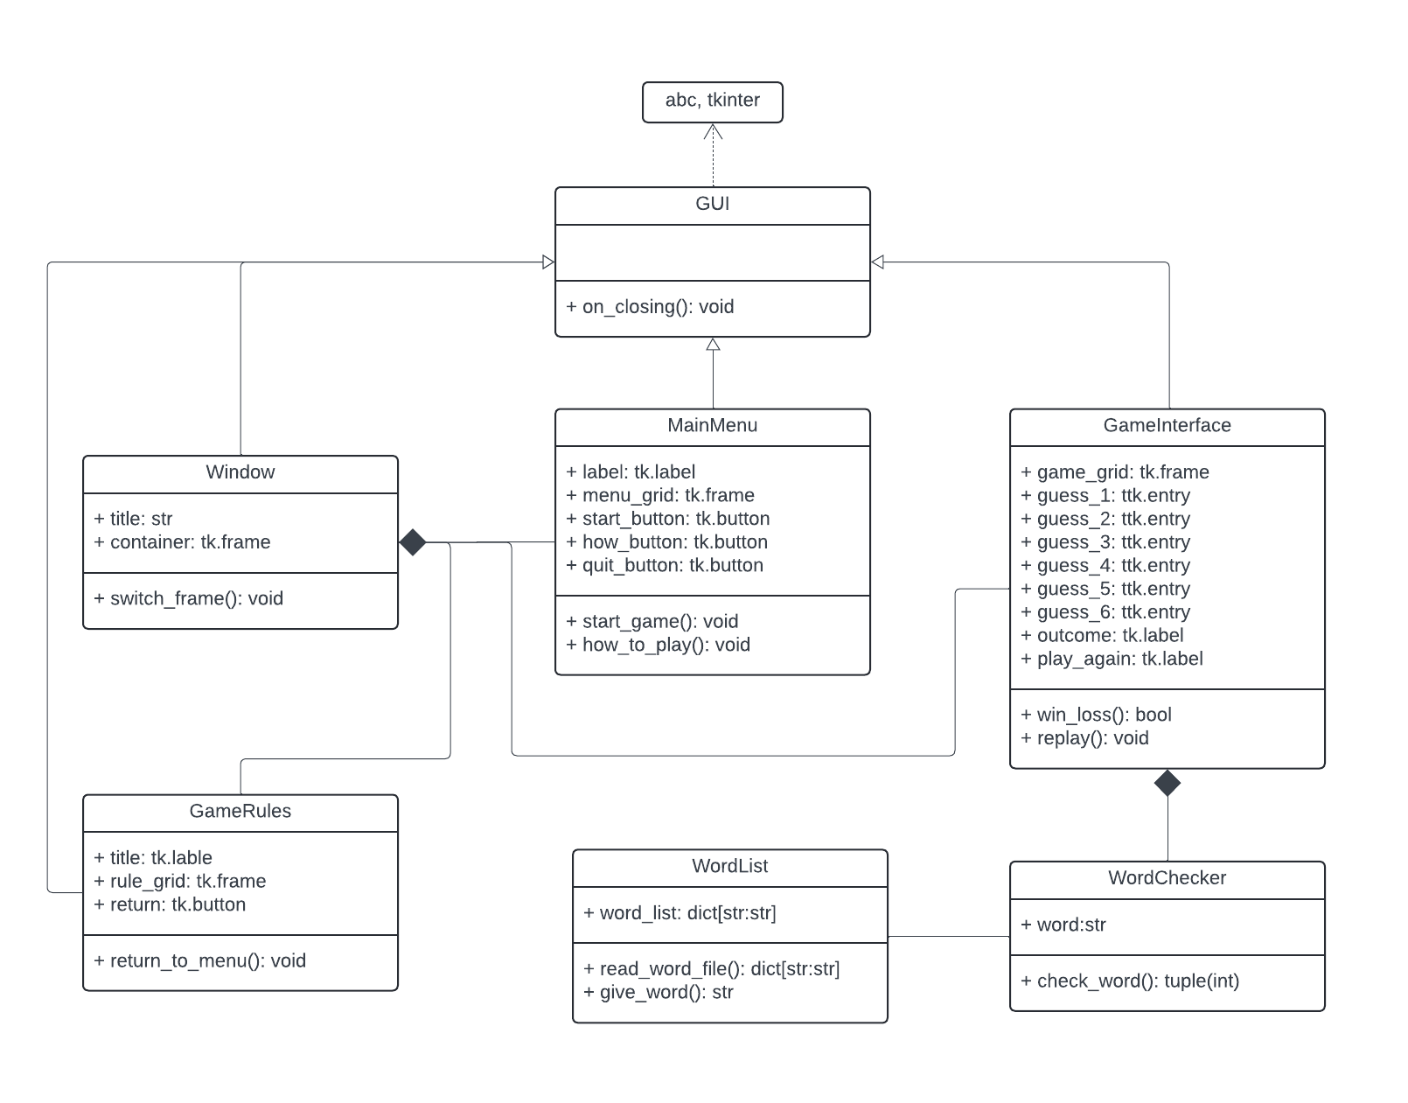gram**

**Class & Method Description**

*GUI Class (Abstract)*

|  |  |
| --- | --- |
| **Method** | **Description** |
| on_closing():void | Handles quitting the app. |

*Window Class*

|  |  |
| --- | --- |
| **Method** | **Description** |
| switch_frame(frame):void | Switch to a different view of the game app. |

*MainMenu Class*

|  |  |
| --- | --- |
| **Method** | **Description** |
| start_game():void | Destroys MainMenu frame object, calls for a GameInterface object to replace it on the Window. |
| how_to_play():void | Destorys MainMenu frame object, calls for a GameRules object to replace it on the Window. |

*GameRules Class*

|  |  |
| --- | --- |
| **Method** | **Description** |
| return_to_menu():void | Destroys GameRules frame object, calls for a MainMenu object to replace it on the Window. |

*GameInterface Class*

|  |  |
| --- | --- |
| **Method** | **Description** |
| win_loss(): bool | If False, feedback is added to the object’s frame indicating a loss to the player. If True, feedback is added indicating a win. In both cases, the replay method is called. |
| replay():void | Adds a button to the object frame that starts a new game with a new word if pressed. |

*WordList Class*

|  |  |
| --- | --- |
| **Method** | **Description** |
| read_word_file(): dict[str:str] | Reads a text file that contains many 5 letter words along with a difficulty value next to it. Stores the words and values in a dictionary. |
| give_word():void | Returns a random word from the dictionary. |

*WordChecker Class*

|  |  |
| --- | --- |
| **Method** | **Description** |
| check_word(): tuple(int) | Returns a tuple with five integers, either 0, 1, or 2. 0 indicates a wrong letter in that index. 1 indicates a correct letter but in the wrong index. 2 indicates a correct letter in the correct index. |

**UI Mockup**

